Name: _____________________________

Homework: Question the Answers 1

I write the answer.
You write the question. Do #1 in class. Do #2 and 3 at home.

Example:
Answer: The pencil is short.

Question: Is the pencil short?

Question: I s t h e p e n c i l s h o r t ?

Answer 1:  The box is big. | 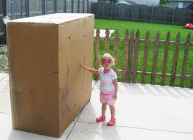
Question: ____ ______ ____ _______?

Answer 2:  The beds are soft. | 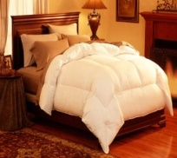
Question: ____ ______ ____ _______?

Answer 3:  The books are thick. | 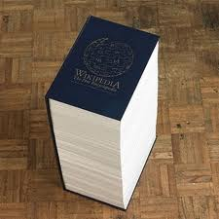
Question: ____ ______ ____ _______?

