Name: _____________________________

Homework: Read the question. Write the answer. Do it at home.

Example: | Question: Is the pencil short?  Answer: The pencil is short.
Answer: The pencil is short .

1) Is the box big? | 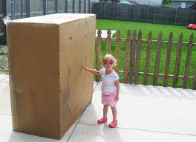
Answer: ______ ______ ___ ______.

2) Are the beds soft? | 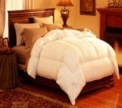
Answer: ______ ______ _____ ______.

3) Are the pencils short?
Answer: ______ ____________ _____ ___________.

4) Is the bed soft?
Answer: ______ ______ ___ ______.

5) Is the pencil short? | 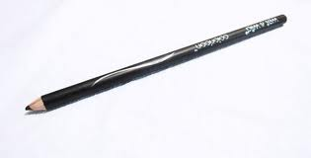
Answer: ______ ____________ _____ ___________.

Homework: Read the answer. Write the question. Do it at home.
Adapted from ESL materials used at NW Seafood Processors.

Example: | Answer: The pencil is short.  Question: Is the pencil short?
Question: Is the pencil short ?

Answer #1:
The girl is small.
Question: _____ ______ ____________ ___________?

Answer #2: The books are thin.
Question: _____ ______ ____________ ___________?

Answer #3: The man is tall.

Question: _____ ______ ____________ ___________?

Answer #4:
The beds are soft.
Question: _____ ______ ____________ ___________?

Answer #5: It is a pencil.
Question: _____ ______ ___ _________________?

