Name: ________________________________

Homework: Spelling & Pronunciation 3

Instructions:
1. Go to the web page, above.
2. Click on the arrow, and listen to the sound.
3. Guess the spelling of the word and write your guess.
4. Click on “Spell” and write the spelling as shown on the site.

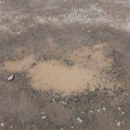 | Your guess:  __ __ __ __ __ __ |  | 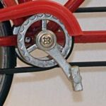 | Your guess:  __ __ __ __ __
copy from site: __ __ __ __ __ __ |  |  | copy from site: __ __ __ __ __
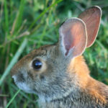 | Your guess:  __ __ __ __ __ __ |  |  | Your guess:  __ __ __ __ __
__ __ __ __ __ __ |  |  | __ __ __ __ __
 | Your guess:  __ __ __ __ __ |  |  | Your guess:  __ __ __ __ __ __
__ __ __ __ __ |  |  | __ __ __ __ __ __
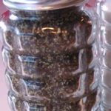 | Your guess:  __ __ __ __ __ __ |  |  | Your guess:  __ __ __ __ __
__ __ __ __ __ __ |  |  | __ __ __ __ __
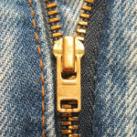 | Your guess:  __ __ __ __ __ __ |  |  | Your guess:  __ __ __ __ __
__ __ __ __ __ __ |  |  | __ __ __ __ __
 | Your guess:  __ __ __ __ __ __ __ __ | 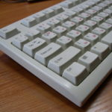 |  | Your guess:  __ __ __ __ __ __ __ __
__ __ __ __ __ __ __ __ |  | __ __ __ __ __ __ __ __
 | Your guess:  __ __ __ __ __ __ |  |  | Your guess:  __ __ __ __ __ __
__ __ __ __ __ __ |  | __ __ __ __ __ __
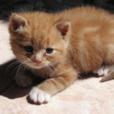 | Your guess:  __ __ __ __ __ __ |  |  | Your guess:  __ __ __ __ __ __
__ __ __ __ __ __ |  | __ __ __ __ __ __
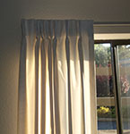 | Your guess:  __ __ __ __ __ __ __ | 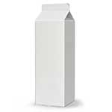 |  |  | Your guess:  __ __ __ __ __ __
__ __ __ __ __ __ __ |  | __ __ __ __ __ __

